Terms of Reference
ISAM Regional Council

Purpose:
The purpose of the ISAM Regional Council is to increase and improve the capability and capacity of addiction medicine globally. This will be through a collegial and collaborative process with ISAM affiliate societies and other country/region specific addiction medicine organizations.
The Regional Council was developed to establish ISAM Affiliate Societies with organizational governance to motivate and promote communication and leadership development from numerous and diverse areas and members internationally throughout the globe. Regional representation of needs, priorities, education, advocacy, and recommendations to the ISAM BOD would thus be enhanced.

Transition to a greater scope of a global representation plan will require the identification and recruitment of Regional Representatives willing to volunteer the time and effort for scheduling conferences in respective time zones and following up with action steps.

Current and future ISAM Affiliate expansion and reach would strategically build upon the current established foundation in a forward continuum, involving interaction with ISAM committees and special interest groups and other ISAM related communities.

THE ISAM REGIONAL COUNCIL
The ISAM Regional Council is composed of individuals who are leaders in the field of addiction and/or specialists in the fields of clinical delivery and leadership, quality improvement, healthcare systems innovation, clinical governance and precision/personalized medicine, with the aim to pursue culture-specific and knowledge-based workstreams globally that will ultimately lead to improvement in clinical care.

This will be accomplished through:
- Gaining an understanding of international, regional, and country-specific needs to help in developing an improvement framework around clinical competencies and evidence-based treatment interventions that can be modified to meet the needs of individuals in all parts of the world
- Identify a sound business plan to make the council self-sufficient financially with expectations from ISAM BOD/Executive to contribute to attracting grants etc. to the overall workings of the ISAM community
- Agreed consensus around clinically relevant topics such as the COVID-19 pandemic and other communicable diseases and substance use disorders, improving the physical and psychological well-being of individuals, psychosocial rehabilitation systems, multiple morbidities and related areas to work with liaison officers from the ISAM-affiliated societies in producing impactful training programs/workshops
- Preparation and facilitation of informed educational/training/conference activities and materials (perhaps in different languages)
- Nominations on a 3 yearly basis for Fellowship status to ISAM members

THE REGIONS
The regional representatives reflect their own area of influence inclusive of overall 15 regions as follows: Eastern Europe, Western Europe, Northern Europe, North America, Central America and Mexico, South America, East Asia, West Asia, Central Asia, South & South-east Asia, North Africa, East, West & South Africa and finally Oceania.
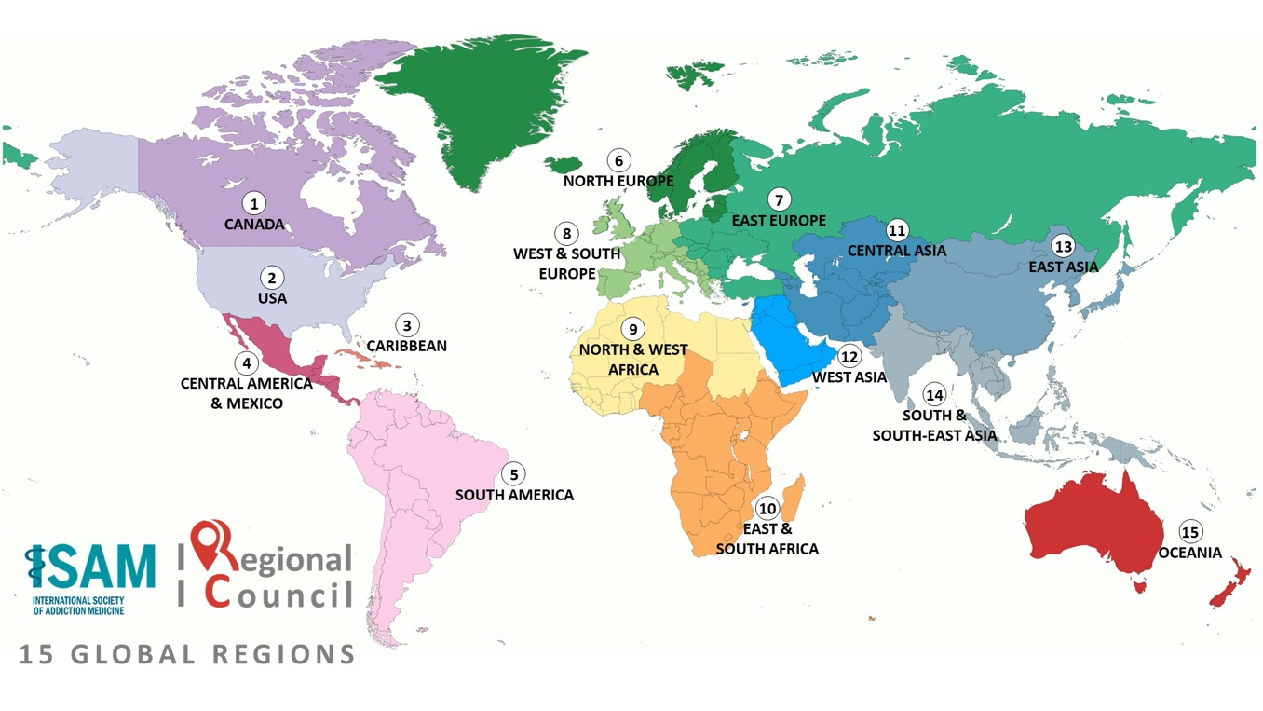

COUNCIL MEMBERSHIP AND PROCEDURES
Membership:
The ISAM Regional Council will consist of (1) Regional Council Chair (2) Regional Council Deputy Chair and (3) 15 ISAM Regional Representatives
- It is expected that all members operate in accordance with ISAM mission, values, goals, and policies
- Members are expected and asked to commit to participating in an active and productive manner.
- Members shall be fully paid ISAM members
- ISAM Regional Council members will be involved, on ad hoc basis, in face-to-face ISAM regional and international meetings, international workshops organized by UN and other agencies, and meetings/webinairs organized by ISAM Affiliated Societies/Organisations and/or virtual equivalents with expectations that they provide their time and expertise without expecting financial benefits

  - ISAM Regional Council Chair

- ISAM Regional Council’s Chair is a full member of the ISAM Board of Directors (BOD)
- The ISAM Regional Council’s chair should be a registered and active ISAM members
- The ISAM Regional Council chair will be elected by the ISAM BOD every 3 years through a fair and open election organized by ISAM office
- Members of the ISAM Regional Council will be highly encouraged to actively participate in the review process for the regional council’s chair candidates.
2. Regional Council Deputy Chair
- ISAM Regional Council’s Deputy Chair is a full member of the Regional Council
- The ISAM Regional Council’s deputy chair should be a registered and active ISAM member as a regional representative.
- The ISAM Regional Council chair will be elected by Regional Council every 3 years through a fair and open election organized by the Regional Council,.
- Members of the ISAM Regional Council will be highly encouraged to actively participate in the review process for the regional council’s chair candidates.

  - Regional Representatives

- Regional representatives will be selected from members of the ISAM BOD, ISAM Past President Council, ISAM Committees, ISAM Special Interest Groups, ISAM NeXT, ISAM current Affiliated Societies/Organisation, ISAM national ambassadors and ISAM global expert network’s active members.
- Nominations will be submitted to the ISAM Regional Council for submission and preparation to ISAM BOD which will approve (or not) these nominations.
- Nominations need to show sound regional professional affiliation, influence and reputation.
- All regional representatives need to be registered and active ISAM members
- Regional representative positions are reviewed every 3 years by the ISAM Regional Council and finally by the ISAM BOD.

This ensures that regional, national and/or multinational affiliate societies will have representatives from all the 15 identified core regions, (either through affiliated societies/organizations representatives and/or individual international credentials), will form part of the ISAM Regional Council.

  - Linked ISAM Regional Council Members

- ISAM Membership, ISAM NeXT, ISAM GEN, ISAM Communications, ISAM Training, ISAM Education and ISAM Finance Committee Chairs and/or delegated authorities of the said committees will be included in the ISAM Regional Council if and when necessary, as those respective areas interface with regional activities

Support:
- The ISAM Regional Council similar to ISAM BOD approved committees and Special Interest Groups (SIG) have notional support from the ISAM office with the expectations that the Regional Council will set up its own secretariat based on a sound financial plan and attraction of new resources
Frequency of Meetings:
- The ISAM Regional Council will meet at least once “in person,” coincident with the annual ISAM scientific meeting and one virtual “Global Assembly of Addiction Medicine Societies” every year.
- Quarterly conference calls for both Eastern and Western hemispheres will be held with workgroups identified to follow-up in the interim with assigned and/or agreed tasks
- Additional meetings will also be held via telephone (teleconference), Skype, Zoom (or equivalent), webinars and/or electronic mail (e-mail) as the need arises.
- All meetings need to have recorded minutes which are then reported to the ISAM BOD on a regular basis for consideration and if needed approval

Decision Making Process:
This will ideally be conducted through a consensus process. In exceptional circumstances when a consensus is unachievable, decisions will be decided by a majority vote.

Reporting Process:
- Regional Representatives will provide a brief quarterly written report to the Chair that will include membership updates, regional meetings, activities, priorities, requests, etc.
- Regional Council Chair will provide a quarterly written report to the ISAM BOD as a member of BOD.
- Regional Council Deputy Chair will participate on behalf of the Regional Council Chair if needed

Approved by ISAM BOD April 2021. Revised March 2023

